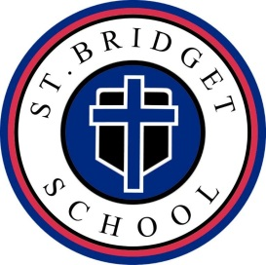
ST. BRIDGET SCHOOL
CHESHIRE

“Fostering academic excellence, community awareness and spiritual growth.”

October 2, 2025

Dear Pre K Families,
Thank you to all the families that have submitted their child’s Flu vaccine documentation. For those families that have not submitted it yet, a friendly reminder it is due by December 31st.
The State of Connecticut requires all students 24 to 59 months of age to receive the Flu Vaccine. The vaccine needs to be received between August 1st and December 31 of this current school year.
Please forward a note from your physician to the health office when your child has received their vaccine. As a reminder we need documentation of those students who have received their Flu vaccine and for those who haven’t please schedule your appointment.
Students will not be permitted to return to school on January 5th, 2026 without documentation of a current Flu vaccination.
Please contact the Health Office with any questions or concerns. Our goal is to keep all students stay and healthy this upcoming Flu season.

Thank you in advance for your cooperation,
Gabriella Connolly, RN
School Nurse
St. Bridget School
Nurse@Stbridgetschool.org

171 MAIN STREET CHESHIRE CT 06410 (203)272-5860 FAX (203)271-7031
www.stbridgetschool.org

